<https://www.youtube.com/watch?v=5koKb5B_YWo&list=PLblh5JKOoLUK0FLuzwntyYI10UQFUhsY9&index=9>

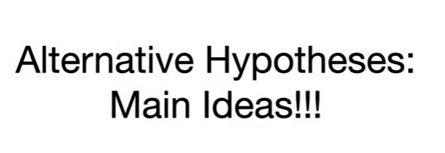

Today we're going to talk about alternative hypotheses.

So that you understand the main ideas.

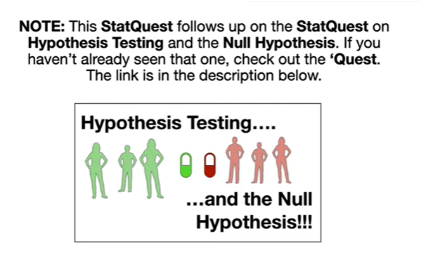

Note : this stat quest follows up on the stat quest on hypothesis testing and the null hypothesis if you haven't already seen that one check out the quest the link is in the description below.

Either way let's do a super quick review.

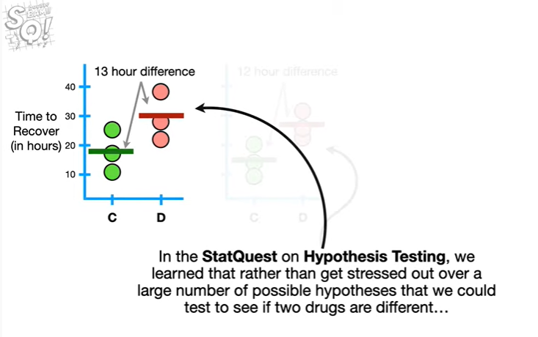

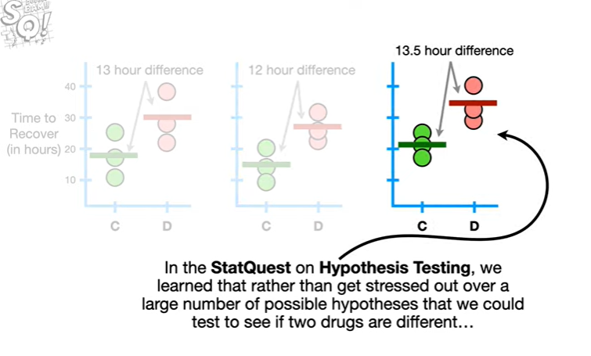

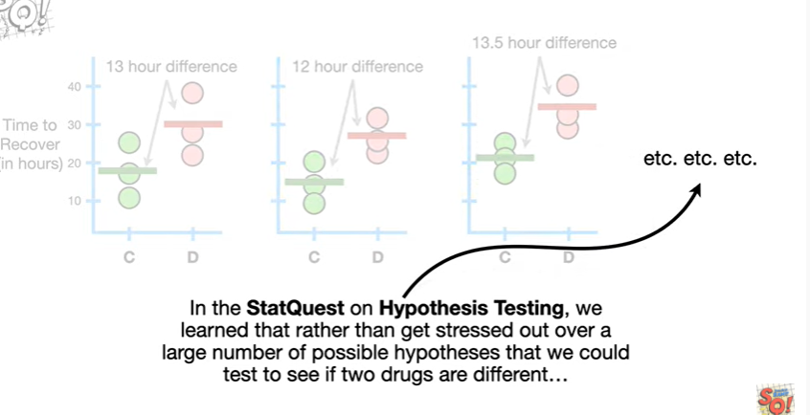

In the stat quest on hypothesis testing, we learn that rather than get stressed out over a large number of possible hypotheses that we could test to see if two drugs are different

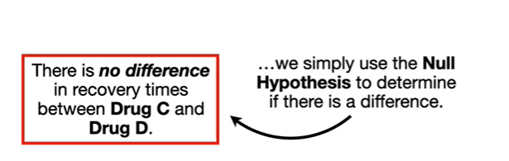

we simply use the null hypothesis to determine if there is a difference.

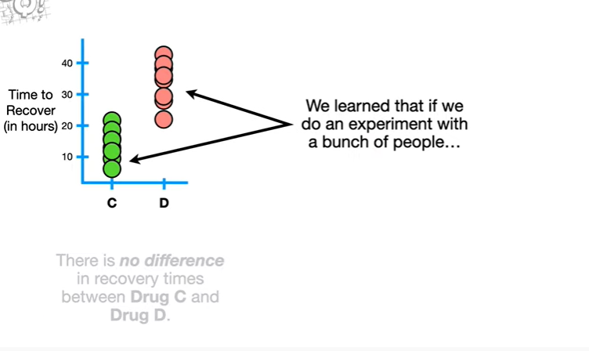

We learn that if we do an experiment with a bunch of people

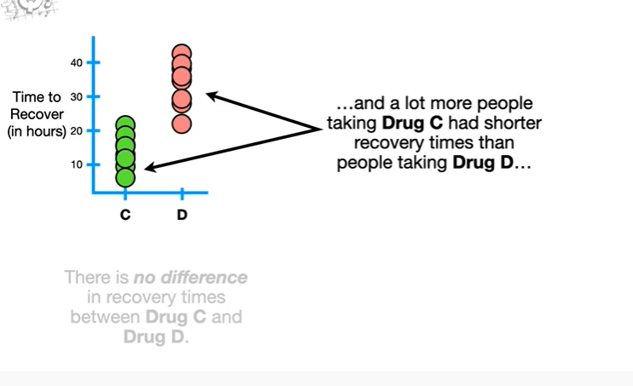

and a lot more people taking drugs see had shorter recovery times than people taking drug D

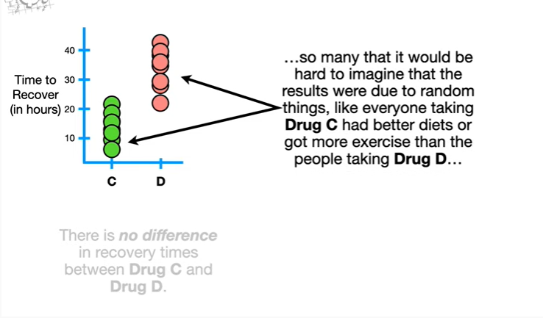

so many that it would be hard to imagine that the results were due to random things like everyone taking drug C had better diets or got more exercise than the people taking drug D

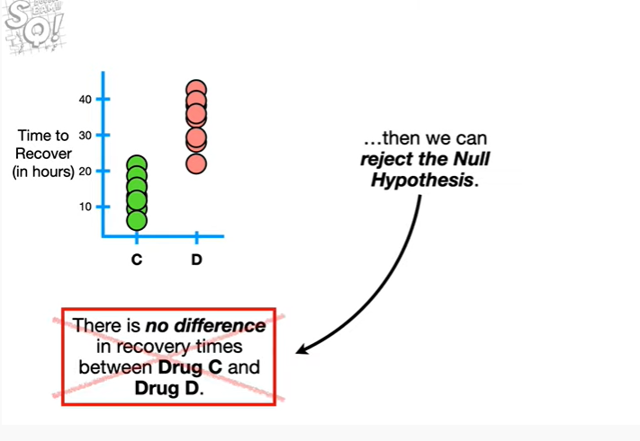

then we can reject the null hypothesis.

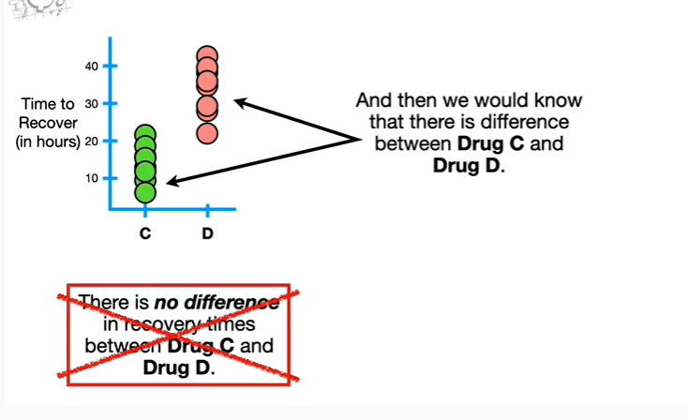

And then we would know that there is a difference between drug C and drug D.

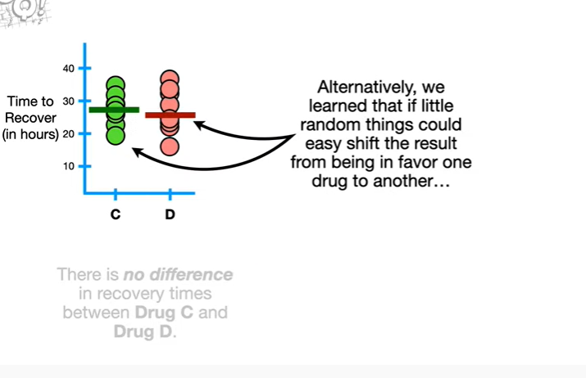

Alternatively we learn that of little random things could easily shift the result from being in favor of one drug to another

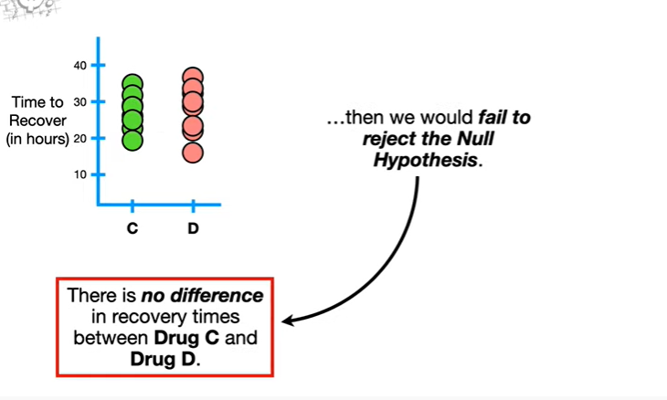

then we would fail to reject the null hypothesis.

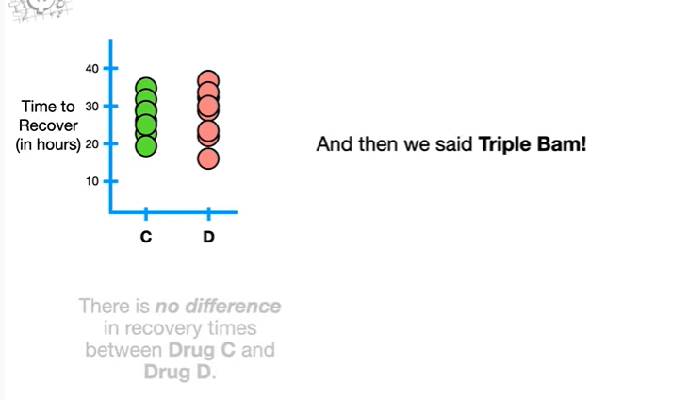

And then we said triple BAM !

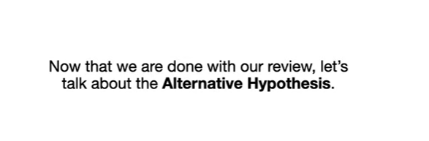

Now that we're done with our review let's talk about the alternative hypothesis.

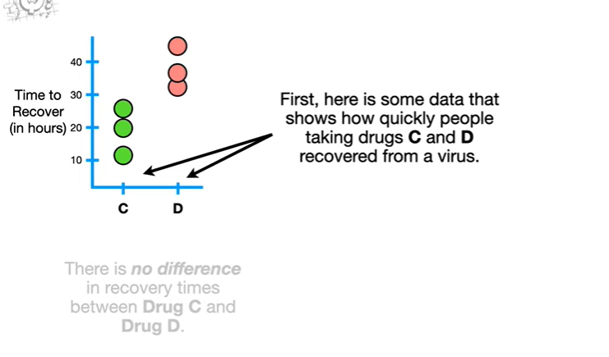

First here's some data that shows how quickly people taking drugs C and D recovered from a virus.

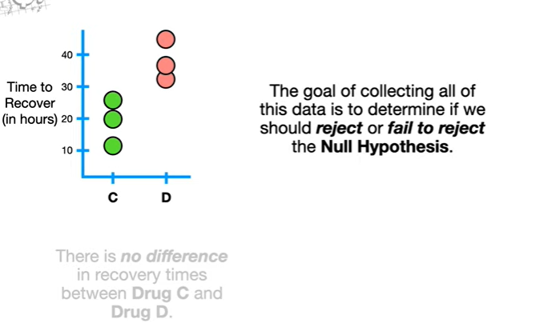

The goal of collecting all of this data is to determine if we should reject or fail to reject the null hypothesis.

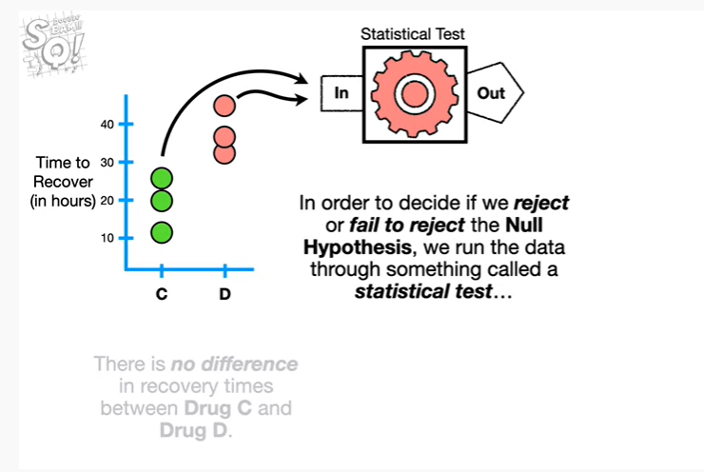

In order to decide if we should reject or fail to reject the null hypothesis we run the data through something called a statistical test

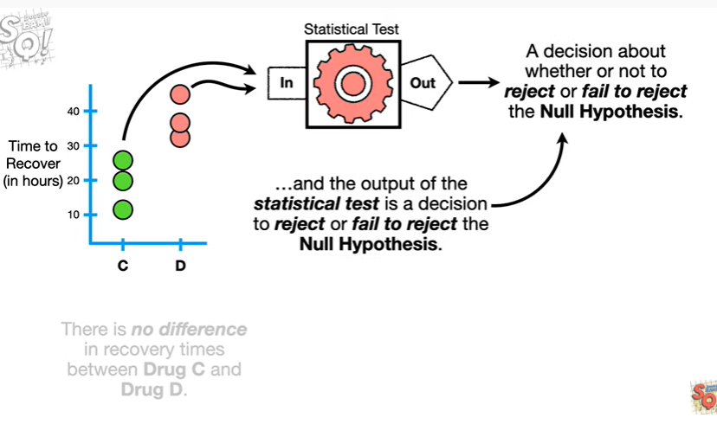

and the output of the statistical test is a decision to reject or fail to reject the null hypothesis.

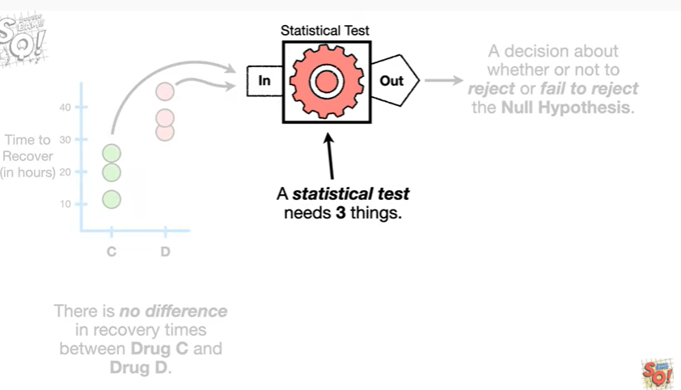

A statistical test needs three things.

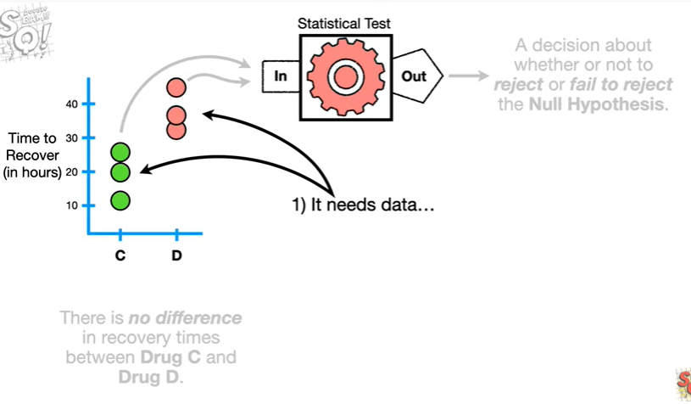

1. it needs data

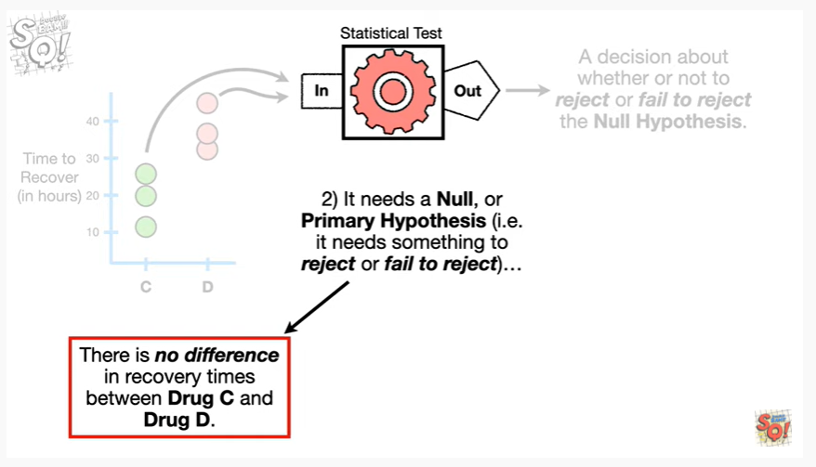

2. it needs a null, or primary hypothesis ie it needs something to reject or fail to reject

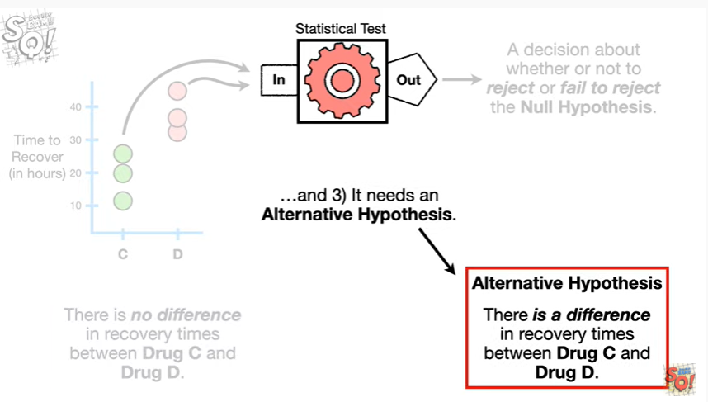

and 3. it needs an alternative hypothesis.

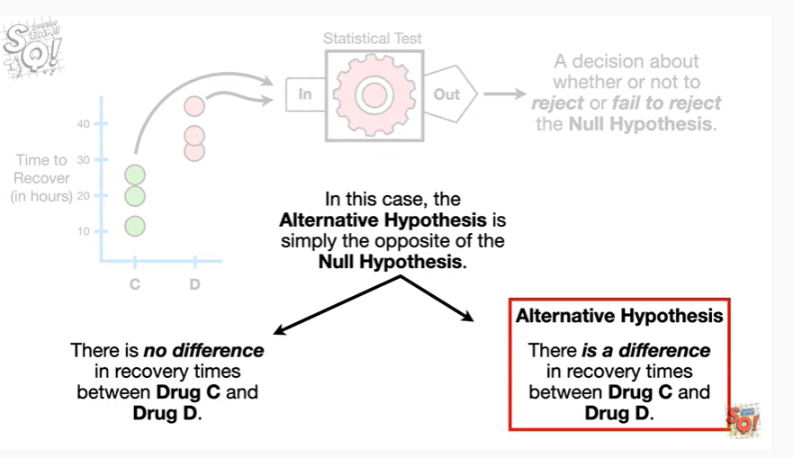

In this case the alternative hypothesis is simply the opposite of the null hypothesis.

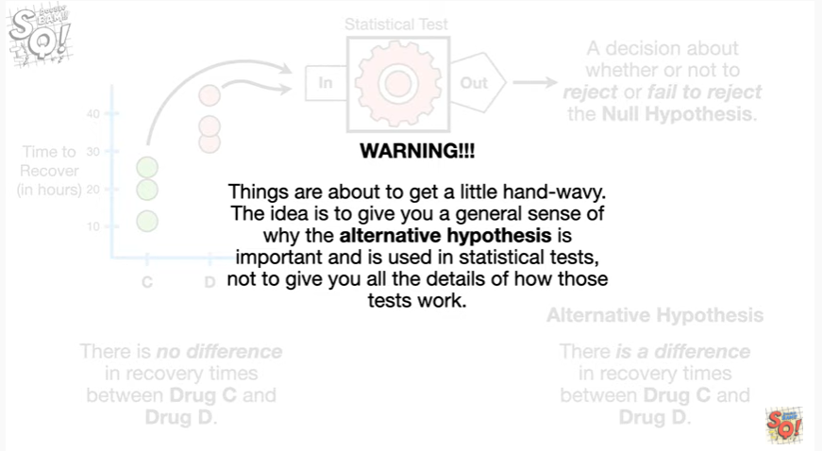

Warning things are about to get a little hand wavey the idea is to give you a general sense of why the alternative hypothesis is important and is used in statistical tests not to give you all the details of how those tests work.

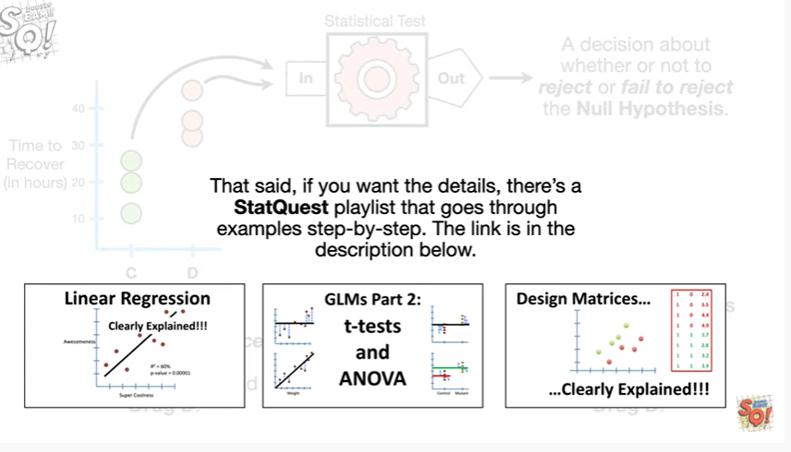

That said if you want the details there's a stat quest playlist that goes through examples step by step the link is in the description below.

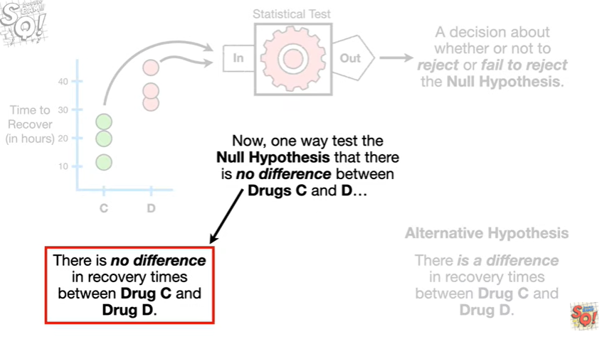

Now one way to test the null hypothesis that there is no difference between drug C and D

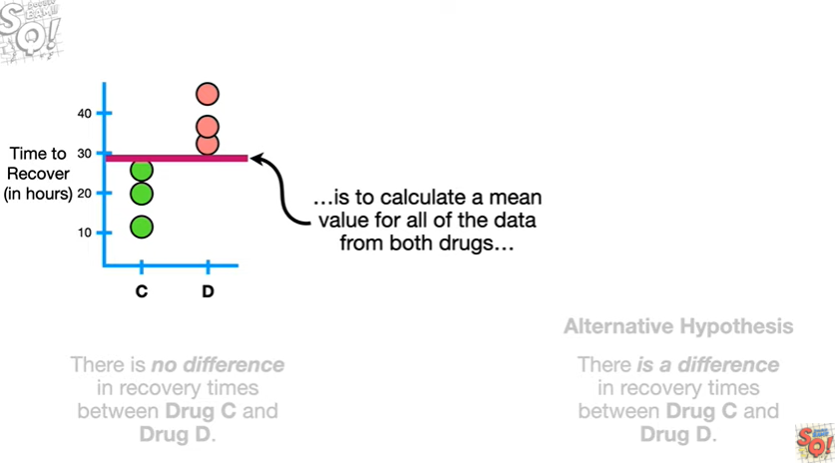

is to calculate a mean value for all the data from both drugs

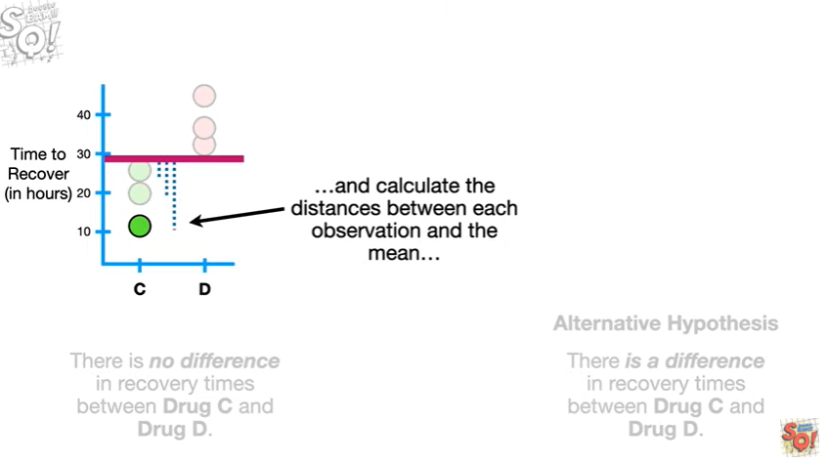

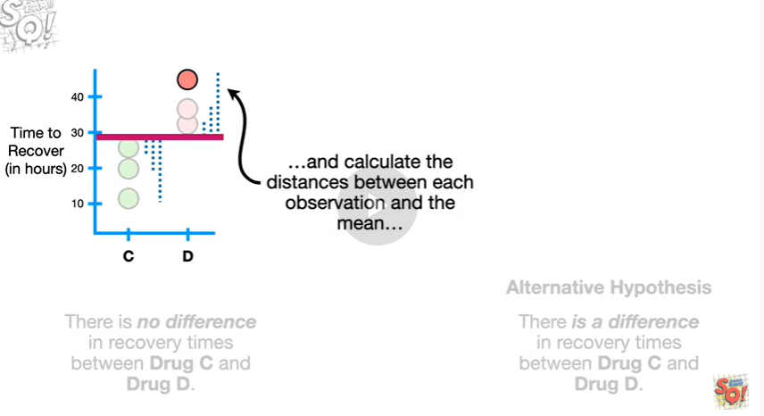

and calculate the distances between each observation and the mean

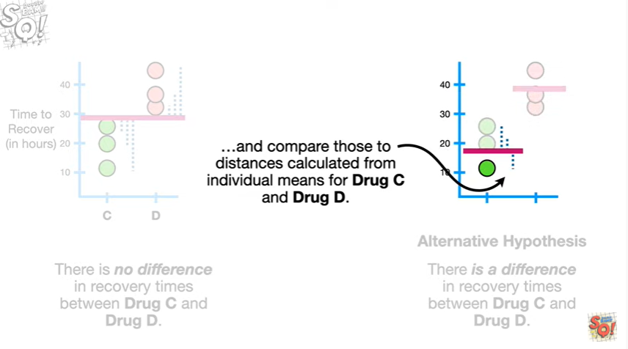

and compare those two distances calculated from individual means for drug C and drug D.

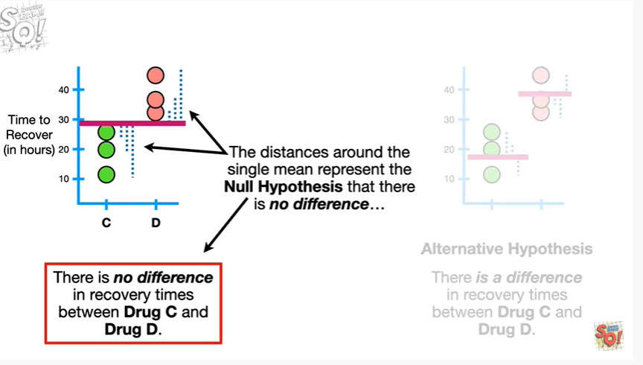

The distances around the single mean represent the null hypothesis that there is no difference

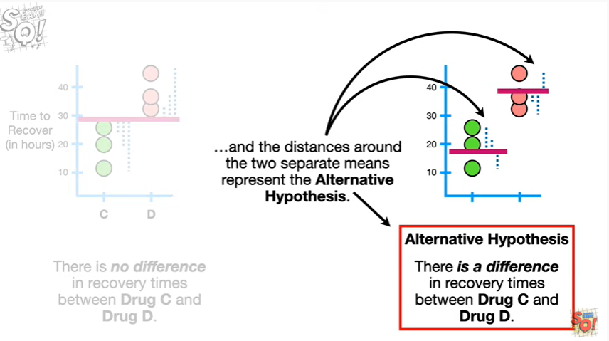

and the distances around the two separate means represent the alternative hypothesis.

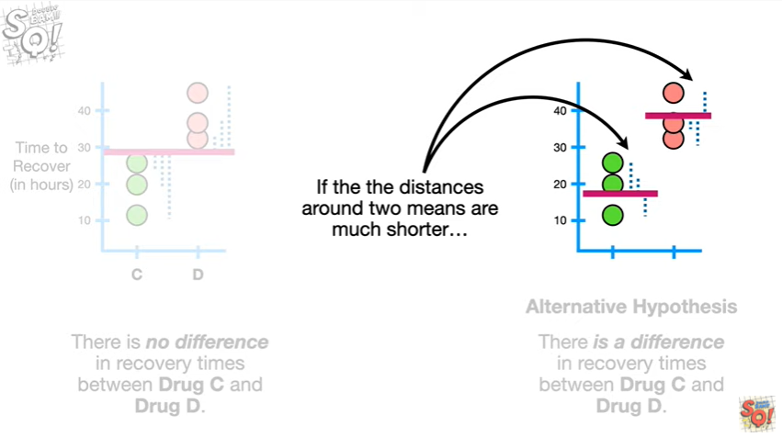

If the distances around two means are much shorter

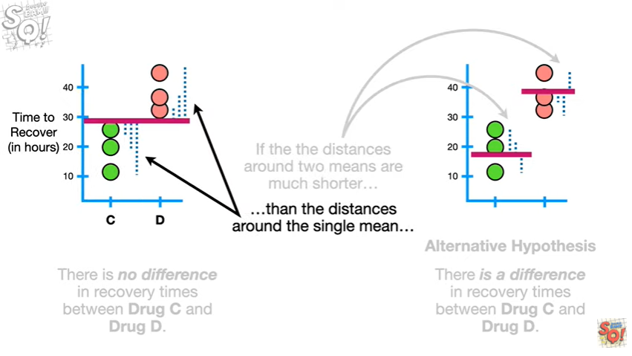

than the distances around the single mean

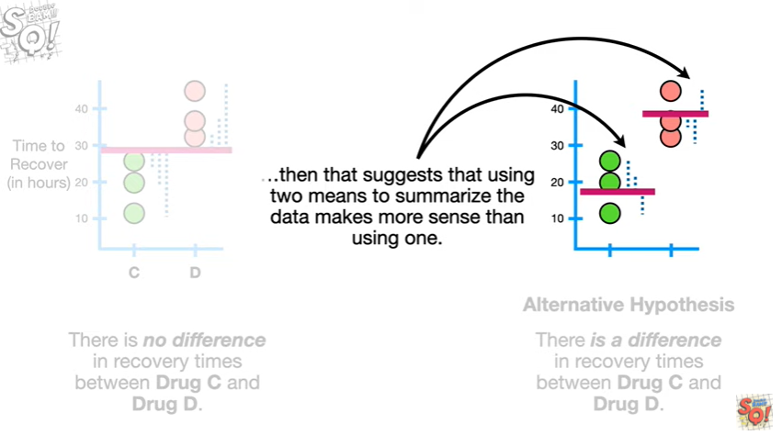

then that suggests that using two means to summarize the data makes more sense than using one.

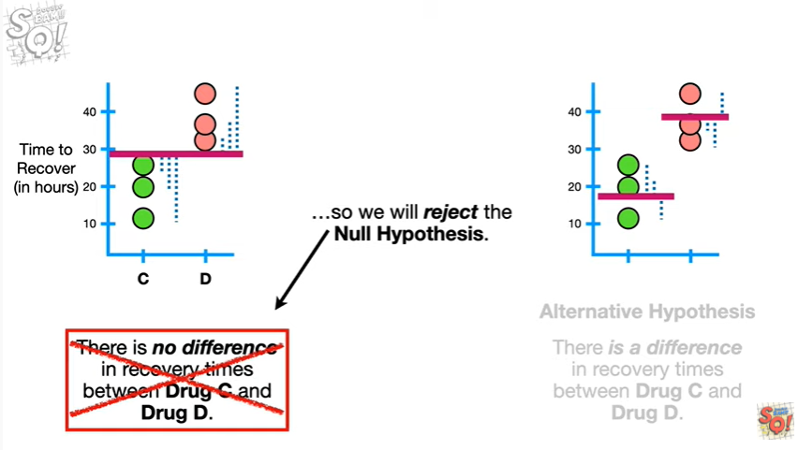

So we reject the null hypothesis.

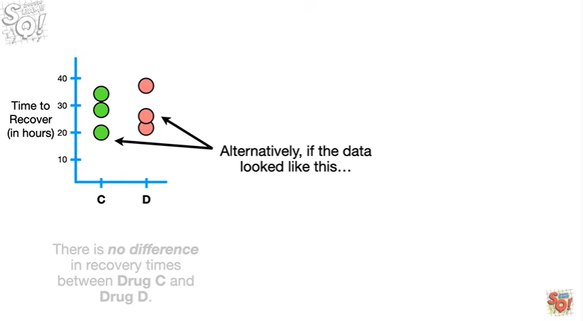

Alternatively if the data looked like this

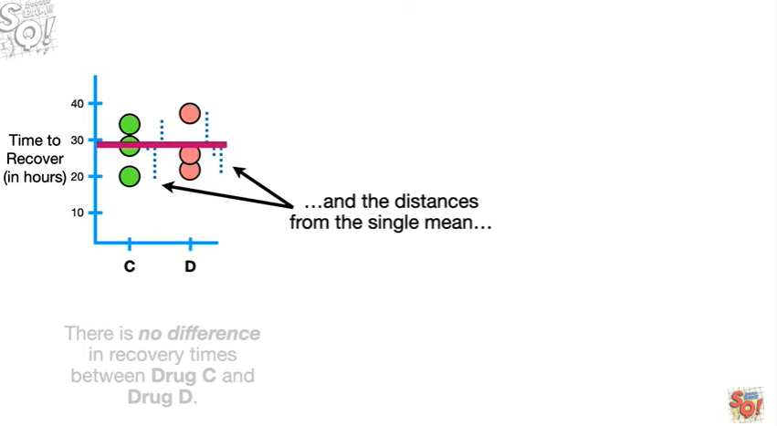

and the distances from the single mean

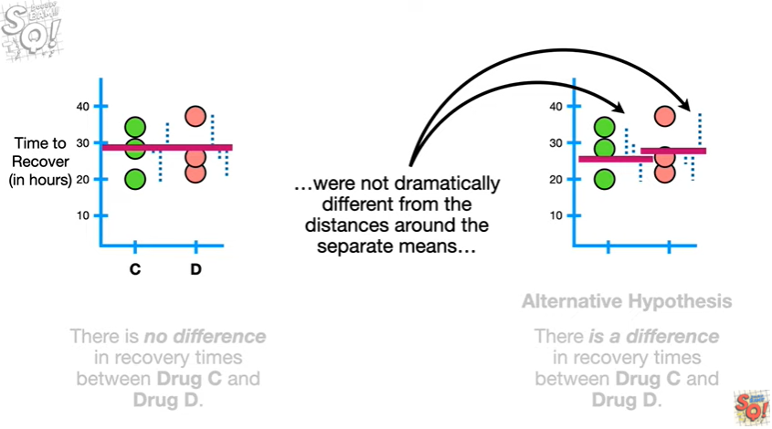

were not dramatically different from the distances around the separate means

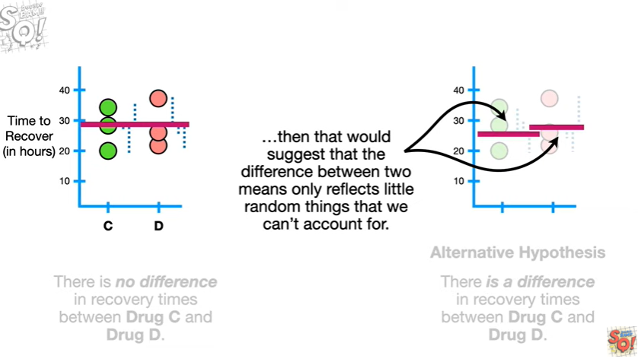

then that would suggest that the difference between two means only reflects little random things that we can't account for.

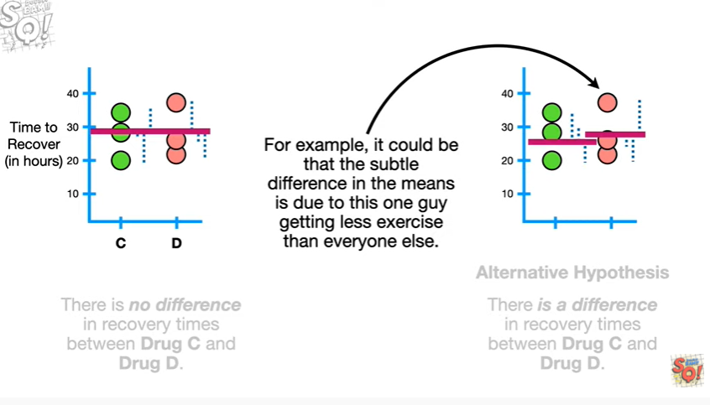

For example it could be that the subtle difference in the means is due to this one guy getting less exercise than everyone else.

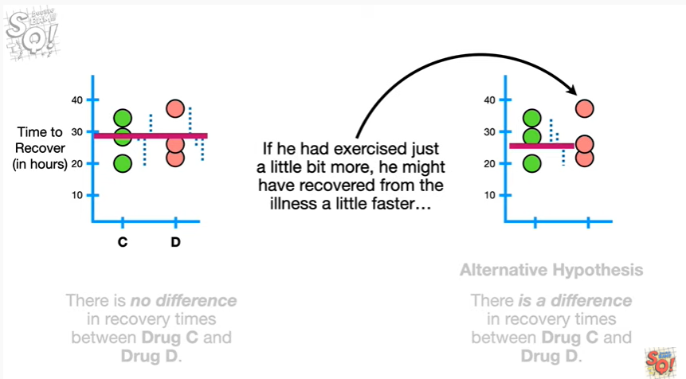

If he had exercised just a little bit more he might have recovered from the illness a little faster

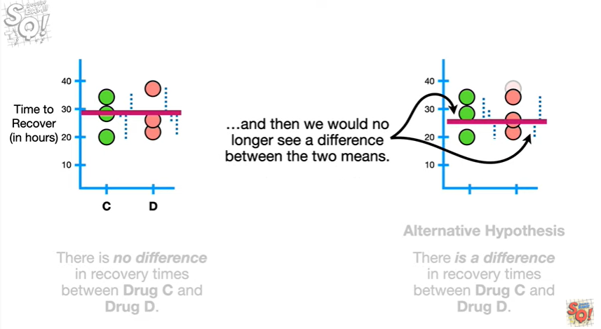

and then we would no longer see a difference between the two means.

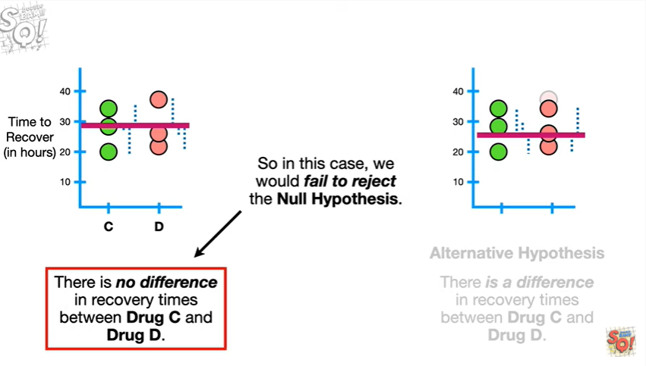

So in this case we would fail to reject the null hypothesis.

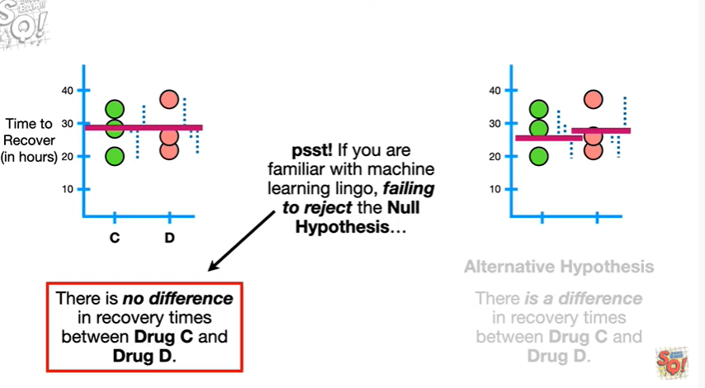

Psst !! If you're familiar with machine learning lingo failing to reject the null hypothesis

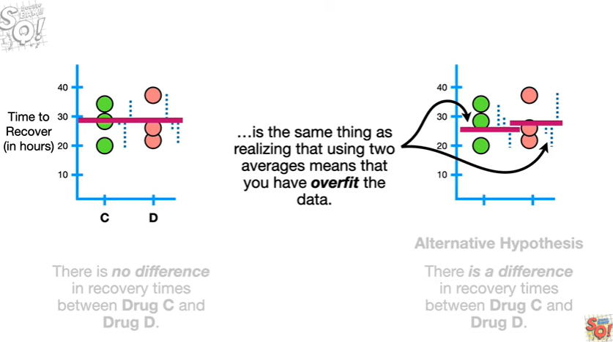

it's the same thing as realizing that using two averages means that you have overfit the data.

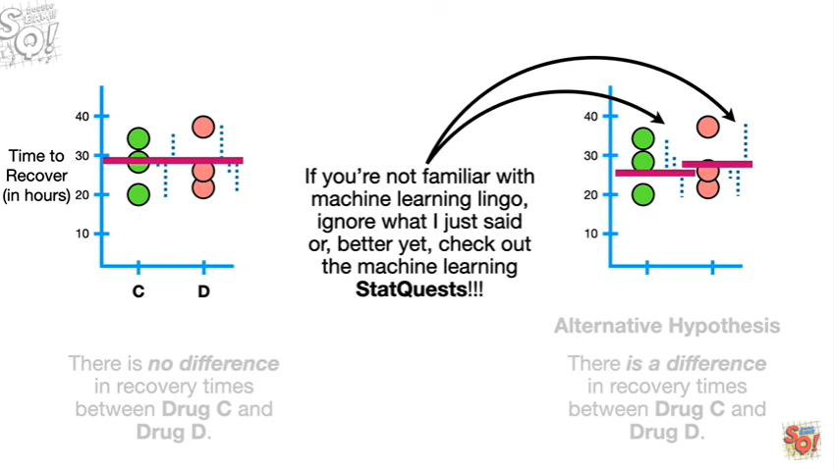

If you're not familiar with machine learning lingo ignore what I just said or better yet check out the machine learning stack Quests !!!

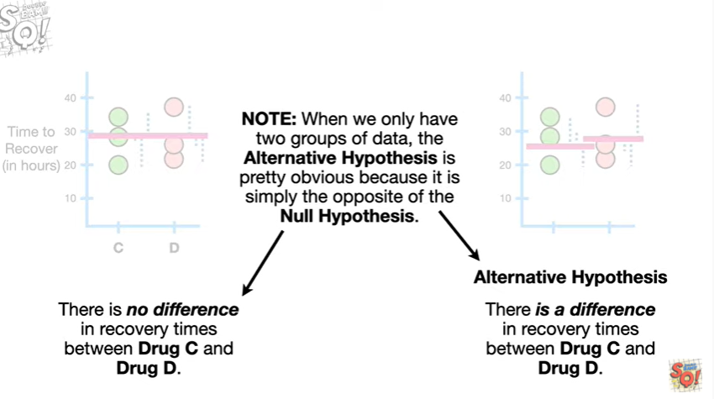

Note : when we only have two groups of data the alternative hypothesis is pretty obvious because it is simply the opposite of the null hypothesis.

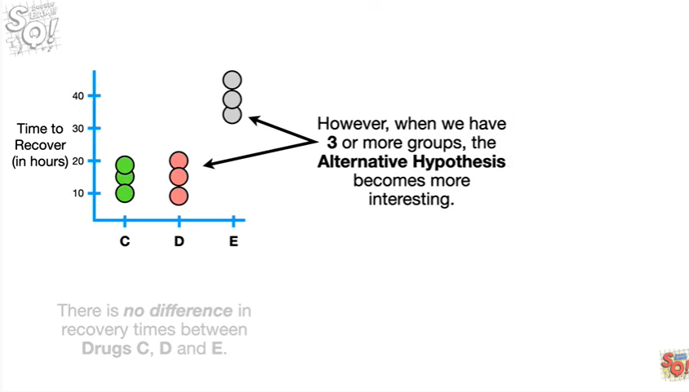

However when we have three or more groups the alternative hypothesis becomes more interesting.

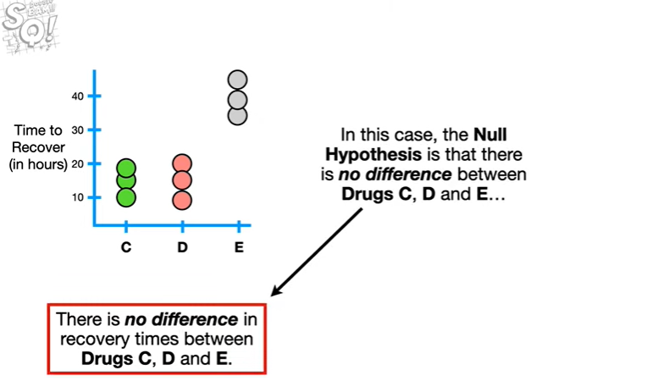

In this case the null hypothesis is that there is no difference between drug C D and E

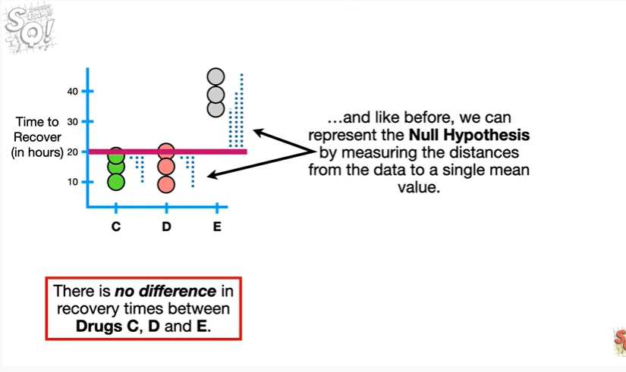

and like before we can represent the null hypothesis by measuring the distances from the data to a single mean value.

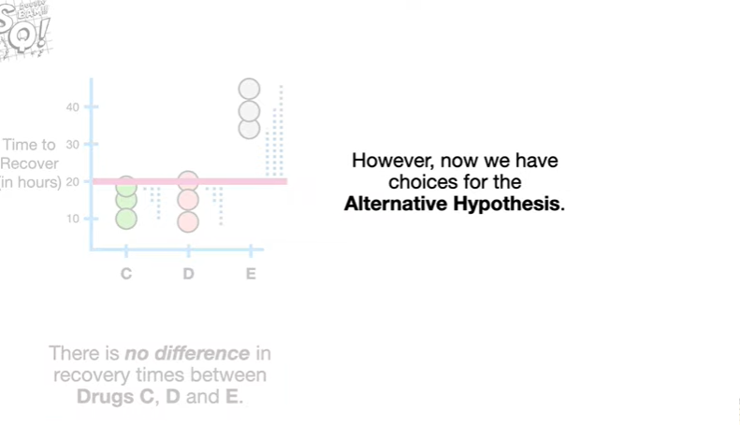

However now we have choices for the alternative hypothesis.

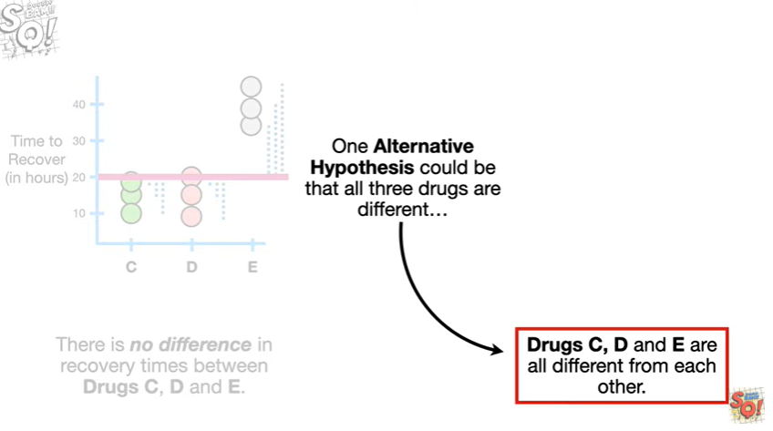

One alternative hypothesis could be that all three drugs are different

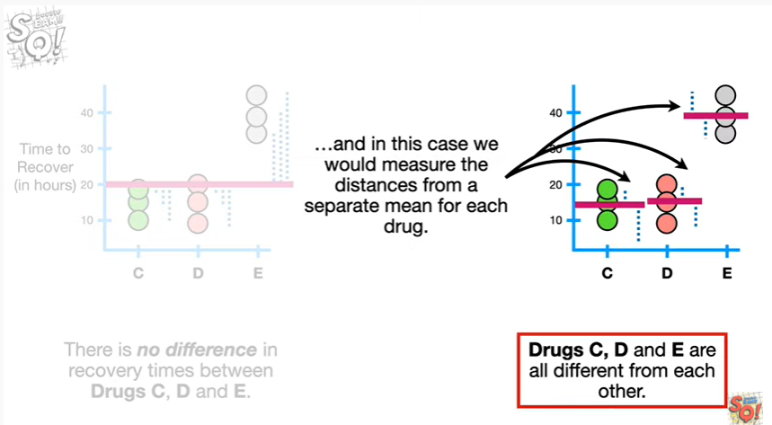

and in this case we would measure the distances from a separate mean for each drug.

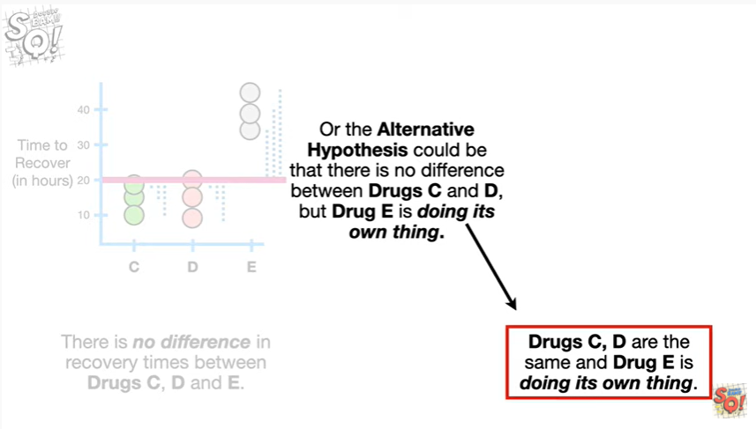

Or the alternative hypothesis could be that there is no difference between drug C and D but drug E is doing its own thing.

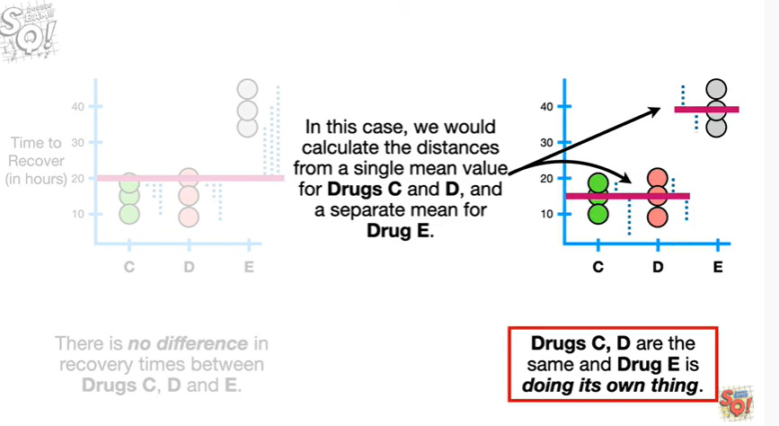

In this case we would calculate the distances from a single mean value for drug C and D and a separate mean for drug E.

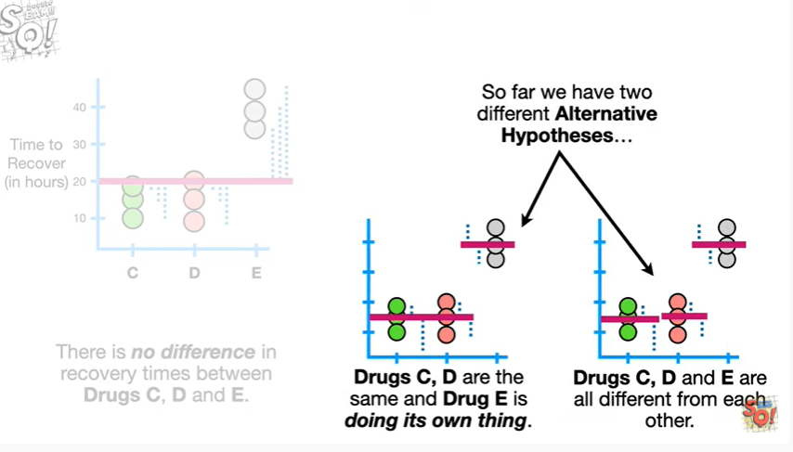

So far we have two different alternative hypotheses

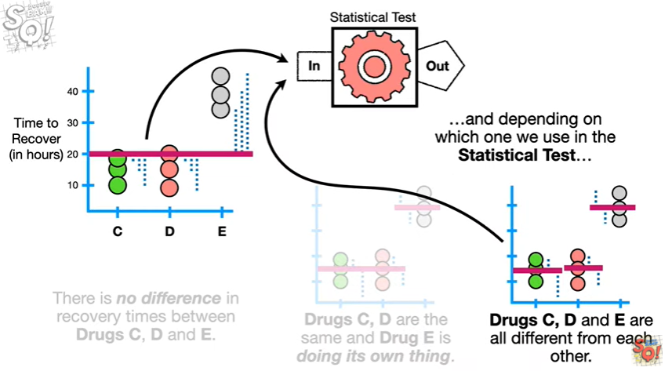

and depending on which one we use in the statistical test

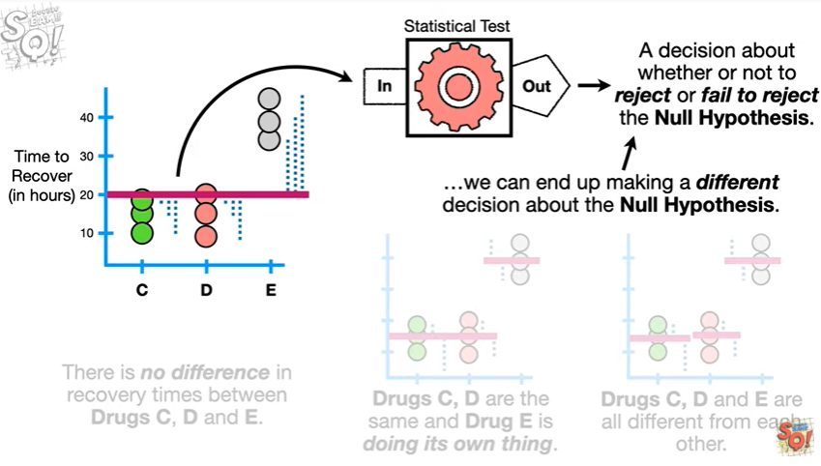

we can end up making a different decision about the null hypothesis.

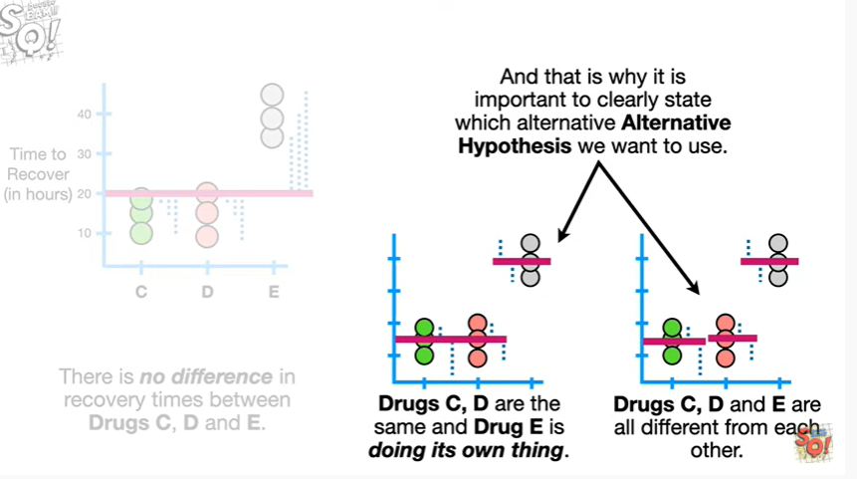

And that is why it is important to clearly state which alternative hypothesis we want to use.

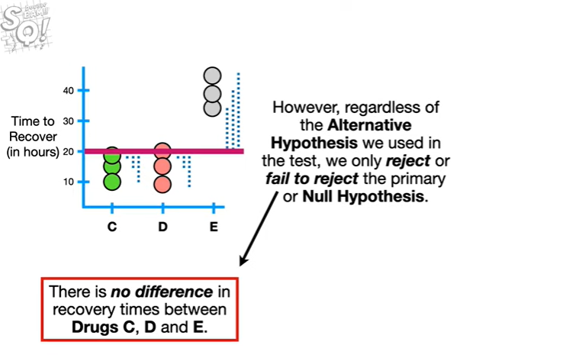

However regardless of the alternative hypothesis we used in the test we only reject or fail to reject the primary or null hypothesis.

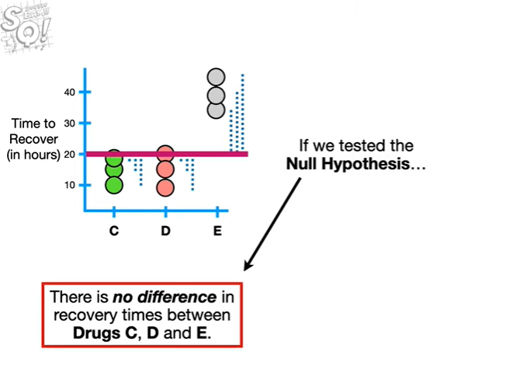

If we tested the null hypothesis

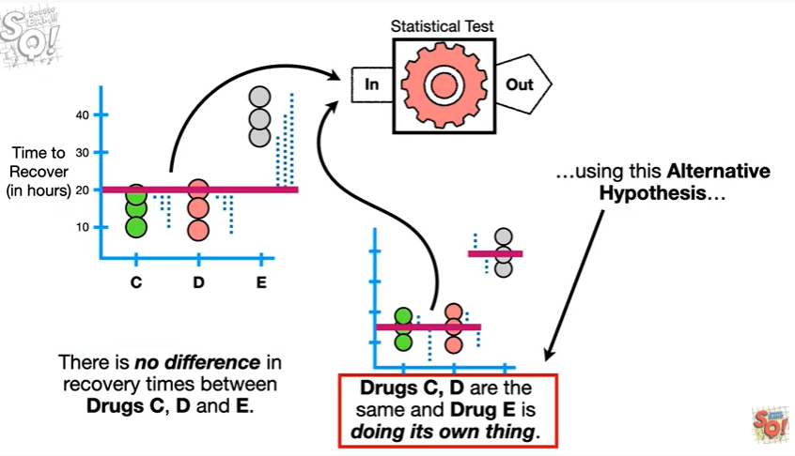

using this alternative hypothesis

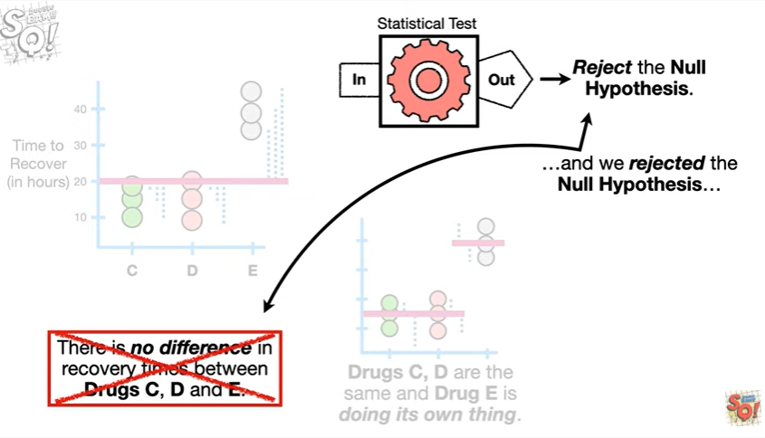

and we rejected the null hypothesis

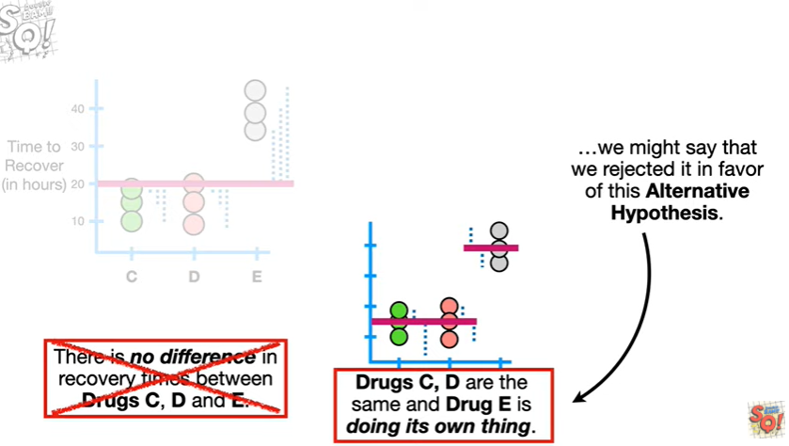

we might say that we rejected it in favor of this alternative hypothesis.

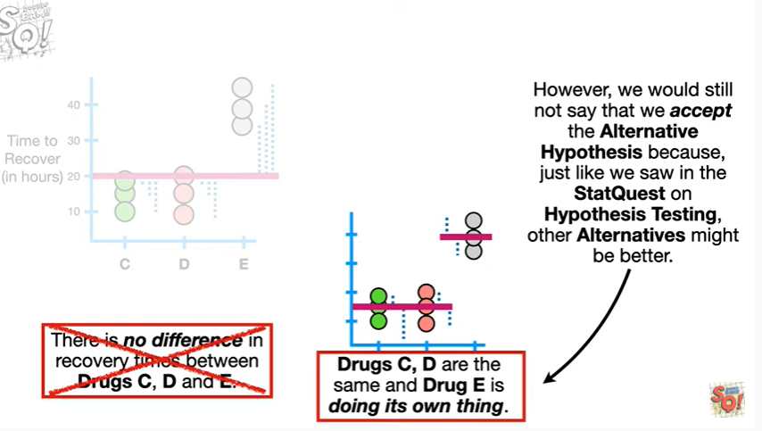

However we would still not say we accept the alternative hypothesis because just like we saw in the stat quest on hypothesis testing other alternatives might be better.

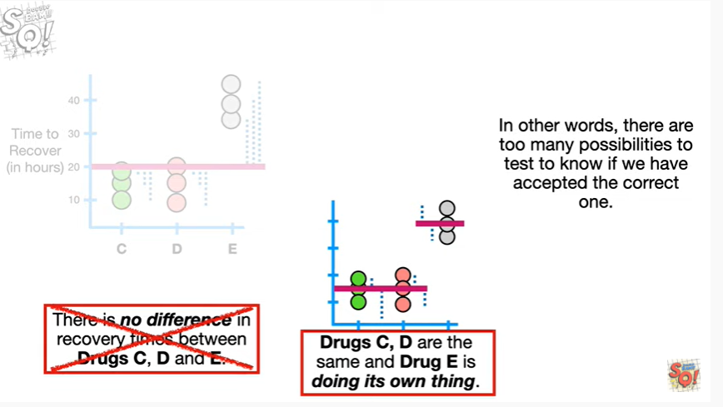

In other words there are too many possibilities to test to know if we have accepted the correct one.

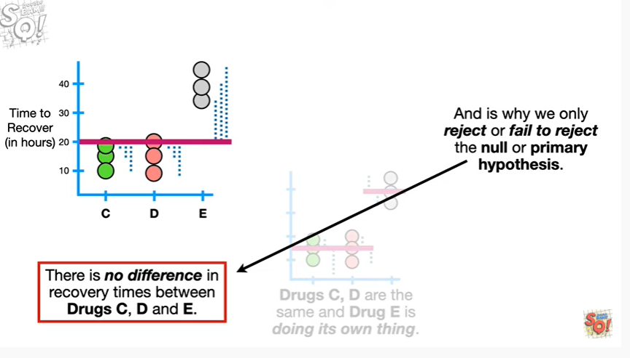

And this is why we only reject or fail to reject the null or primary hypothesis.

BAM !!!



In summary :

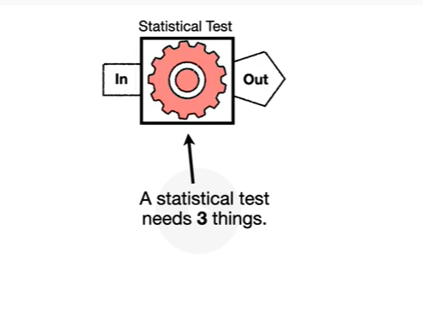

a statistical test needs three things

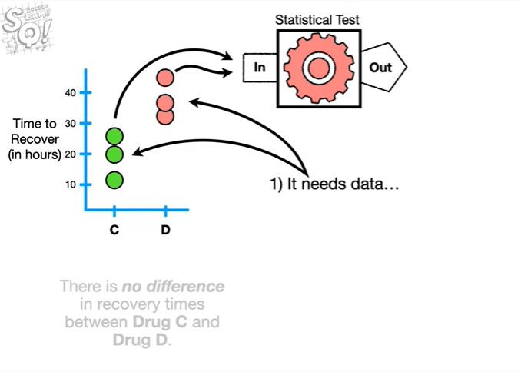

1. it needs data

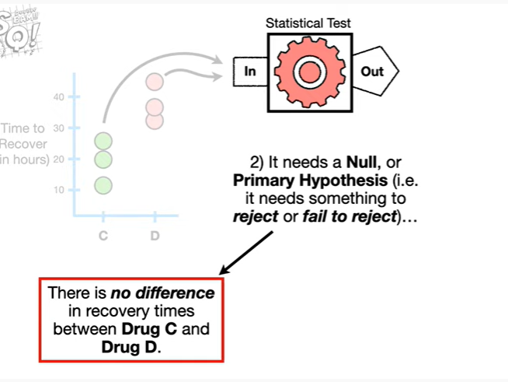

2. it needs a null or primary hypothesis

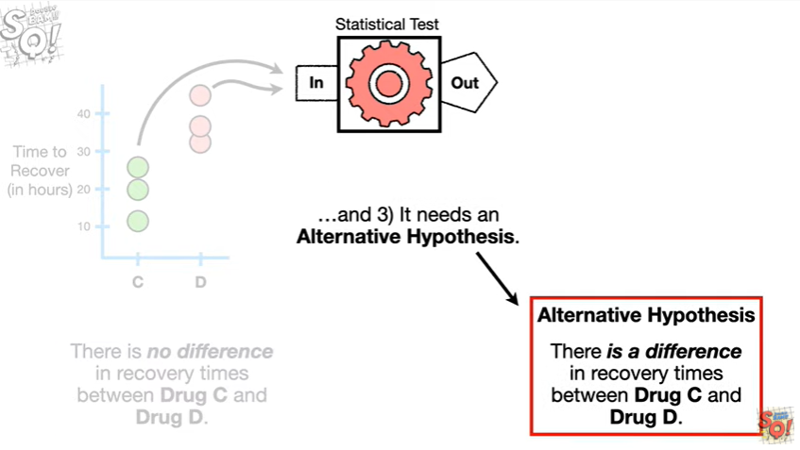

and 3. it needs an alternative hypothesis.

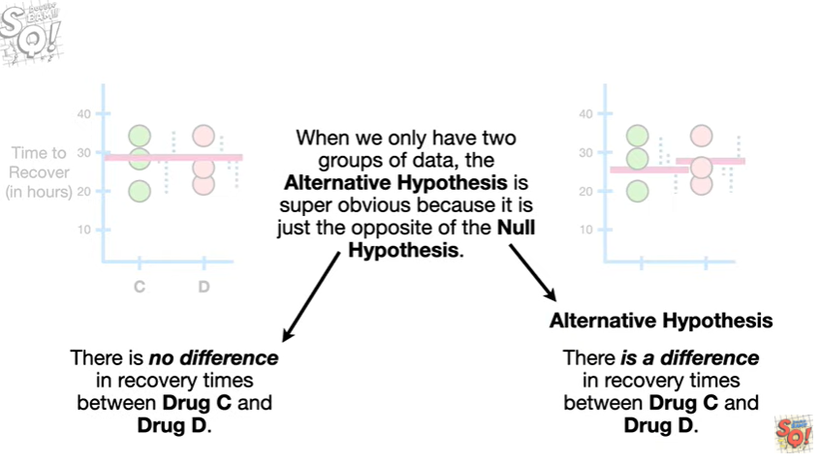

When we only have two groups of data the alternative hypothesis is super obvious because it is just the opposite of the null hypothesis.

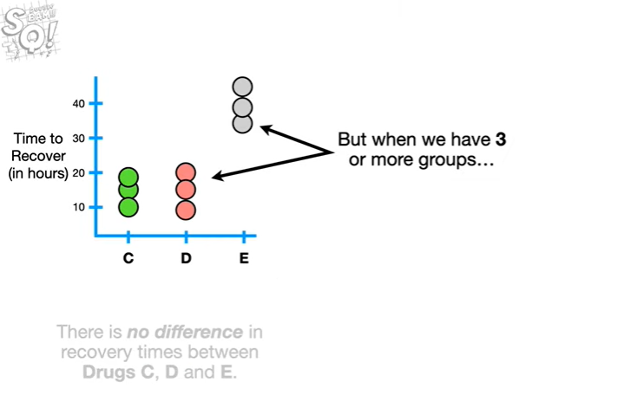

But when we have three or more groups

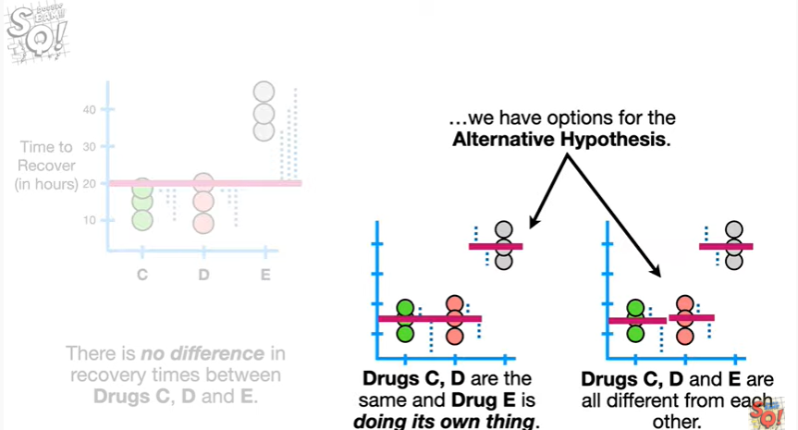

we have options for the alternative hypothesis

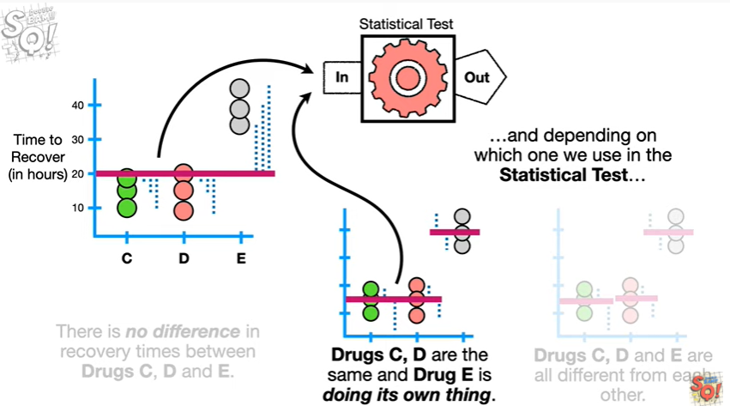

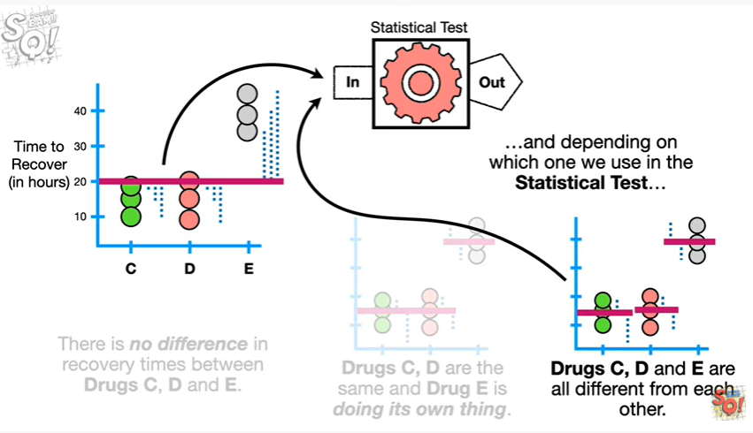

and depending on which one we use in the statistical test

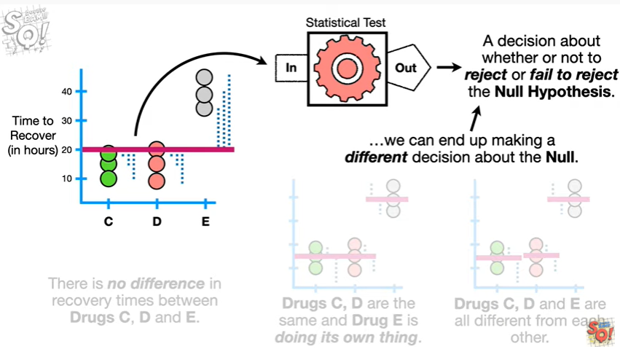

we can end up making a different decision about the null.

Double bam !!!

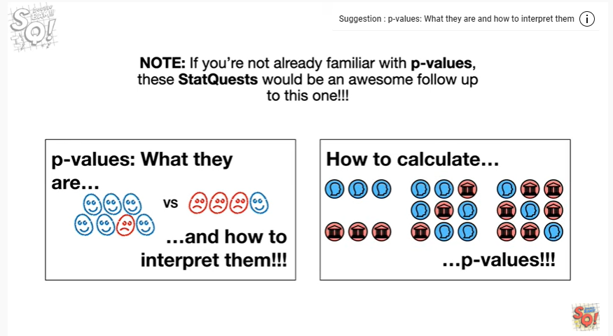

Note : if you're not already familiar with p-values these stat quests would be an awesome follow-up to this one !!!

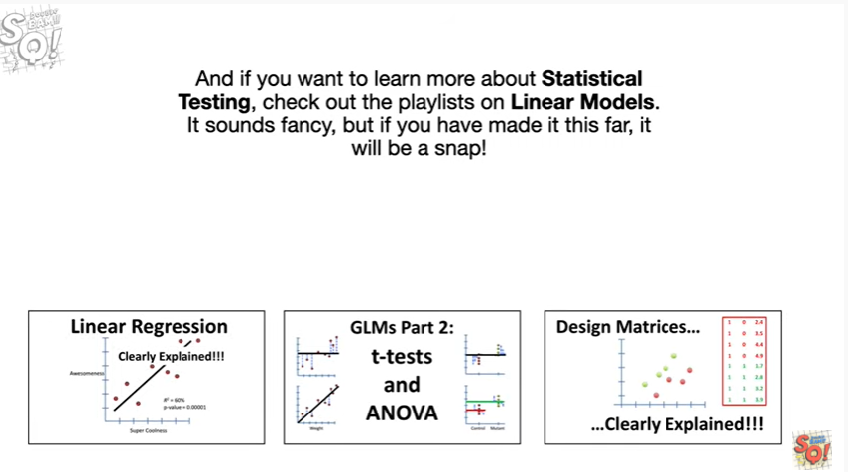

And if you want to learn more about statistical testing check out the playlist on linear models it sounds fancy but if you've made it this far it will be a snap !